How does our PSHE Curriculum support children to understand and develop positive relationships?
Our PSHE Curriculum at Harrison Primary covers three core themes: Relationships, Health and Well-being and Living in the Wider world.
Explicitly, through our Relationship themed units, we teach the fundamental building blocks and characteristics of positive relationships; focusing on friendships, family relationships and relationships with other children and adults. Relationships Education is also taught within the other core themed units, as all three themes are overlapping and linked.
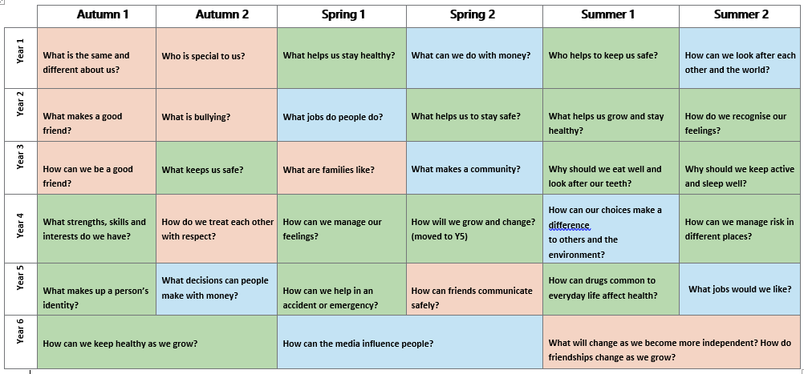
In Foundation Stage (EYFS) and key stage 1, this begins with the children learning about:
- what a relationship is
- what friendship is
- what family means
- who the people are that can support them
Working in harmony, with both our School Values and our Harrison Tree, through Relationships Education pupils are also taught about:
- how to take turns
- how to treat each other with kindness, consideration and respect
- the importance of honesty and truthfulness
- the importance of permission seeking and giving
- the Concept of personal privacy
- establishing personal space and boundaries
- showing respect
- understanding the differences between appropriate and inappropriate or unsafe physical and other contact (these are the forerunners of teaching about consent, which takes places at Secondary School)
From the beginning of Primary School, we discuss the features of healthy friendships, family relationships and other relationships that young children are likely to encounter. The intended outcome is to enable our children to gain a strong understanding of the features of relationships likely to lead to happiness and security. In addition, it will also help them to recognise any less positive relationships when they encounter them.
Our PSHE Curriculum also addresses internet safety and appropriate behaviour as the core principles of positive relationship also apply virtually. Our content includes, how information and data are shared and used in a range of contexts, for example, sharing pictures, understanding that many websites are businesses and how sites may use information provided by users in ways they may not expect.
It is a statutory requirement for all schools to teach children the knowledge they need to recognise and to report abuse. Within our PSHE Curriculum, we teach this in an age appropriate way, focusing on boundaries and privacy, including that they have rights over their own bodies. The children are taught to understand boundaries in friendships with peers, in families and others, and online.
Our approach towards teaching PSHE also embodies the core values of positive relationships, for example, the use of ground rules in PSHE sessions. Ground rules are an agreement owned by the children about how they will behave towards each other in discussion. Please see below for examples of possible ground rules offered by the PSHE Association:
• Openness: We will be open and honest, but not discuss directly our own or others’ personal/private lives. We will discuss examples but will not use names or descriptions which could identify anyone.
• Keep the conversation in the room: We feel safe discussing issues and we know that our teacher will not repeat what is said in the classroom unless they are concerned we are at risk, in which case they will follow the school’s safeguarding policy.
• Non-judgmental approach: It is okay for us to disagree with another person’s point of view but we will not judge, make fun of, or put anybody down. We will ‘challenge the opinion, not the person’
. • Right to pass: Taking part is important. However, we have the right to pass on answering a question or participating in an activity and we will not put anyone ‘on the spot’.
• Make no assumptions: We will not make assumptions about people’s values, attitudes, behaviours, identity, life experiences or feelings. We will listen to the other person’s point of view respectfully and expect to be listened to ourselves.
• Using appropriate language: We will use correct terms rather than slang terms, as they can be offensive. If we are not sure what the correct term is, we will ask our teacher.
• Asking questions: We are encouraged to ask questions and they are valued by our teacher. However, we do not ask personal questions or anything intended to deliberately try to embarrass someone.
• Seeking help and advice: If we need further help or advice, we know how and where to seek it—both in school and in the community. We will encourage friends to seek help if we think they need it.
Our shared School Values, Ethos, Harrison Tree and our PSHE Curriculum work hand in hand to promote, encourage, foster and recognise the positive personal attributes and character traits needed to form positive strong relationships.

